Stage Sight

Individual Members Application Form.

YOUR DETAILS

Name?
Email address
What is your job title?

What can Stage Sight do for you?

Stage Sight wants to put members voices at the centre of its work. We respond to your needs.

Would you be interested in these opportunities?
 | Drop in sessions once a month with no set topic.
 | Be involved in a Stage Sight Steering Group
 | Attend events with other individual members
 | Attend events with organisational members
 | Forums focused on a topic
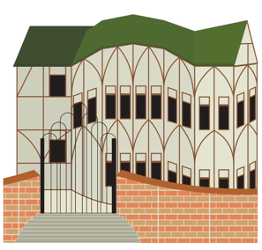 | One-off conversation with a Stage Sight Organisation
 | None of the above
Other:

Which organisational staff member would it be most helpful for you to have a single conversation with?

Artistic Director
Executive Director
Producer
Technical Director/ Production Manager

Chair/ Trustee.
Other:

Which type of organisation would you like to speak with?

 | Regularly Funded Organisation
 | Independent organisation (non-regularly funded)
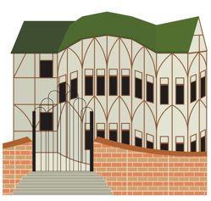 | Venue
 | Touring organisation
 | Commercial organisation
 | Industry body
 | Funder
 | Union
 | None of the above

Other:

Would you be interested in any of the following mentoring systems?
Peer to Peer
A staff member from a Stage Sight organisation member
None of the above
Other:

Is there anything else that Stage Sight could support you with, or any other ideas that you would like us to offer?

What can you do for Stage Sight?

Stage Sight is a non-funded organisation, meaning its members and committee work on a free, voluntary basis. If fees are offered for external events then these are paid to those who represented Stage Sight at said events.

Would you be willing to support Stage Sight in any of the following ways?
This information will be included in your profile on the Stage Sight website.

Be a mentor
Talk with organisations about your experiences
Attend events as a Stage Sight representative
Other:

Areas of Interest: Stage Sights 3 strands of work.
We ask all new members to commit to actively working to increase diversity in off stage roles. The three areas we focus on are Recruitment, Reaching Out and New Pathways.
Please let us know which area(s) you are interested in with, and in what ways.

This information will be included in your profile on the Stage Sight website.

Recruitment:

Changing recruitment practices to become more open and inclusive.

Your Answer:

Reaching Out:

Raising awareness of and improving the visibility of off stage roles to the public

Your Answer:

New Pathways:

Developing new learning and training experiences

Your Answer:

Your Stage Sight Profile.

Individuals who are part of the Stage Sight will be featured on our website. This information will all be included on your profile.

Please give a brief description of your work and why you have joined Stage Sight. And a website address if you have one.

Your Answer:

www.

If you wish for Stage Sight to engage with you on Instagram and Twitter please include your @s or tags.

Your Answer:

Thank you for completing this application form.

Please return this to admin@stagesight.org

